**Date: 25.04.2025**

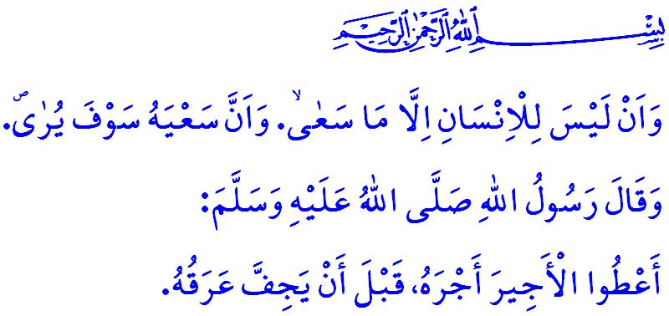

**THE SWEAT OF ONE’S BROW IS SACRED**

**Honorable Muslims!**

One day, as our beloved Prophet (saw) was conversing with his companions, a strong and towering man passed by. Some of the companions, struck by the man’s imposing presence, remarked, “O Messenger of Allah! If only this man would use his strength in the way of Allah!” To this, our Prophet (saw) replied: **“If he strives to provide for his family and children, he is in the way of Allah. If he works to support his parents, he is in the way of Allah. And if he toils to preserve his own honor and dignity, then he is also in the way of Allah.”[1]**

**Dear Believers!**

Our sublime religion, Islam, regards it as an act of worship for a person to earn a livelihood for themselves and their family through halal and legitimate means, by adhering to the commands and prohibitions of Allah the Almighty, and to work without becoming a burden on others. It holds labor and the sweat of one’s brow as sacred and honorable. It forbids laziness, idleness, begging, and the squandering of time and one’s life. Allah the Almighty has advised us to work in order to achieve peace in this world and the Hereafter by stating, **“... Each person will only have what they endeavored towards, and that ˹the outcome of˺ their endeavors will be seen ˹in their record˺...”[2]**

**Esteemed Muslims!**

Our religion places great emphasis not only on the halal nature of one’s earnings but also on the legitimacy of the means by which they are acquired. For this reason, there are principles and guidelines regarding employment, the establishment of businesses, and the earning of income. It is not permissible to buy or sell that which Allah has declared haram. Therefore, a Muslim is prohibited from producing, buying, selling, using, or contributing to the use of alcohol, which destroys the mind and will, and leads to accidents and homicides. The Muslim is also prohibited from engaging in, having others engaged in, or providing means for gambling, which tears families apart and inflicts irreparable harm on social life. They cannot receive, charge, or facilitate interest, which erodes the blessings of wealth and life and stands in opposition to labor and the sweat of the brow. They are prohibited from engaging in and derive profit from haram acts such as black marketeering, usury, and hoarding, which disrupt social harmony.

**Dear Believers!**

In Islam, being an employee also entails certain responsibilities. The employee should regard the workplace and its materials as a trust, and must never cause harm to them. They must not use any items from the workplace for personal purposes, nor should they disclose confidential information to others. They must respect working hours and avoid causing any setback in their work. They should be respectful towards their colleagues, uphold their rights as their own, and diligently avoid any behavior that may cause them harm.

**Dear Muslims!**

Islam also places numerous responsibilities upon the employer. The employer is obliged to pay the employee their full wages promptly, in accordance with the warning of our Prophet (saw): **“Give the workers their wages before their sweat dries.”[3]** Therefore, in the name of cheap labor, the employer cannot subject the employee to harsh conditions with a low wage, nor deprive them of their social rights.

The employer is also responsible for ensuring that the employee’s basic human needs and rights are met. For this reason, the employer cannot prevent the worker from performing the five daily prayers and the Friday prayer on time, from observing the fast, or from adopting the tasattur, which is a command of Allah the Almighty and an adornment of the believer, especially when the verse of Allah the Almighty, **“…Indeed, performing prayers is a duty on the believers at the appointed times.”[4]** is clearly evident. Additionally, the employer cannot deny the employee their rest hours, weekly or annual leave.

The employer is obliged to protect the rights and law of the employee, in compliance with the command of our Almighty Lord:  **فَلَا تَتَّبِعُوا الْهَوٰٓى اَنْ تَعْدِلُواۚ** **“… Do not let your desires cause you to deviate ˹from justice˺...”[5]** For this reason, the employer cannot exert systematic pressure on the employee. The employer must not engage in words, actions, or behaviors that could harm the employee’s honor, chastity, or dignity. The employer cannot fire the employee unjustly or victimize their family and children.

The employer is also responsible for ensuring the safety of the workplace and providing the employee with a healthy work environment. No employee can be employed in a work that endangers their life or compromises their mental, physical, or spiritual health. In this regard, our Prophet’s (saw) warning is very clear: **“Whoever harms others, Allah will harm them. Whoever causes hardship to others, Allah will bring hardship upon them.”[6]**

**Dear Believers!**

In the sight of Allah, there is no superiority between an employer and an employee. Superiority lies in taqwa, that is, to fear Allah as He ought to be feared, to fulfill His commands, and to refrain from His prohibitions. Therefore, let us prioritize the approval of our Lord, justice, fairness, honesty, and winning hearts above all worldly gains. Let us not forget that peace and happiness are not found solely in consuming and accumulating, but also in sharing and being content.

I would like to conclude this Friday’s khutbah with our beloved Prophet’s (saw) following hadith: **“... No one will die without receiving the sustenance that Allah has decreed for them, whether sooner or later. So, fear Allah and seek your sustenance through lawful means. Take what is halal and avoid what is haram.”[7]**

1. 1 Tabarani, Mu’jam al-Awsat, VII, 56.
2. Najm, 53/39, 40.
3. Ibn Majah, Ruhun, 4.
4. Nisa, 4/103.
5. Nisa, 4/135.
6. Abu Dawud, Qada’ (Aqdiyyah), 31.
7. Ibn Majah, Tijarah, 2.

   ***General Directorate of Religious Services***